**Swimmer Detection**

**허재호**

**Train Data Results**

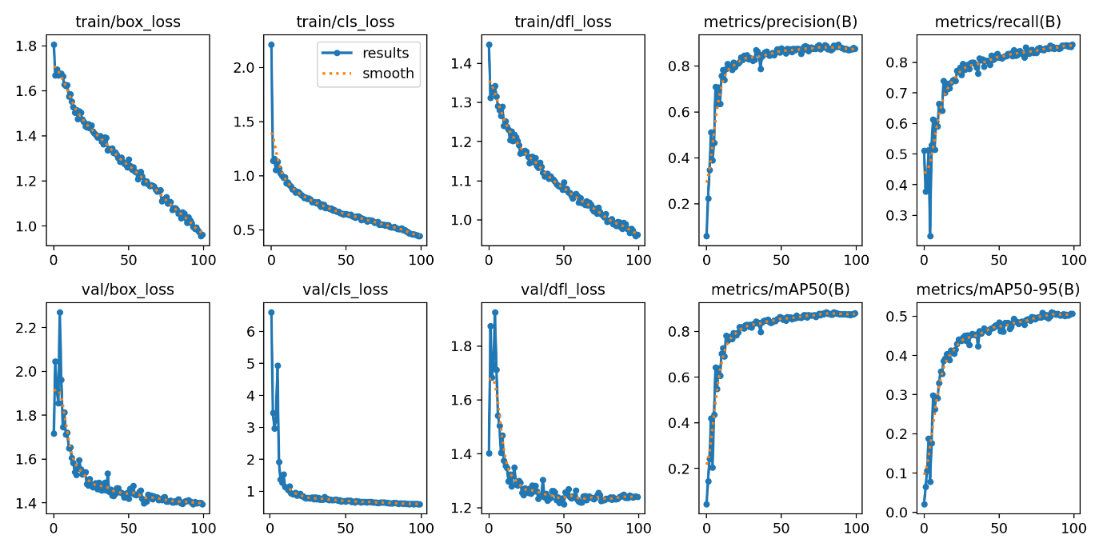

**Train + Val Data results**

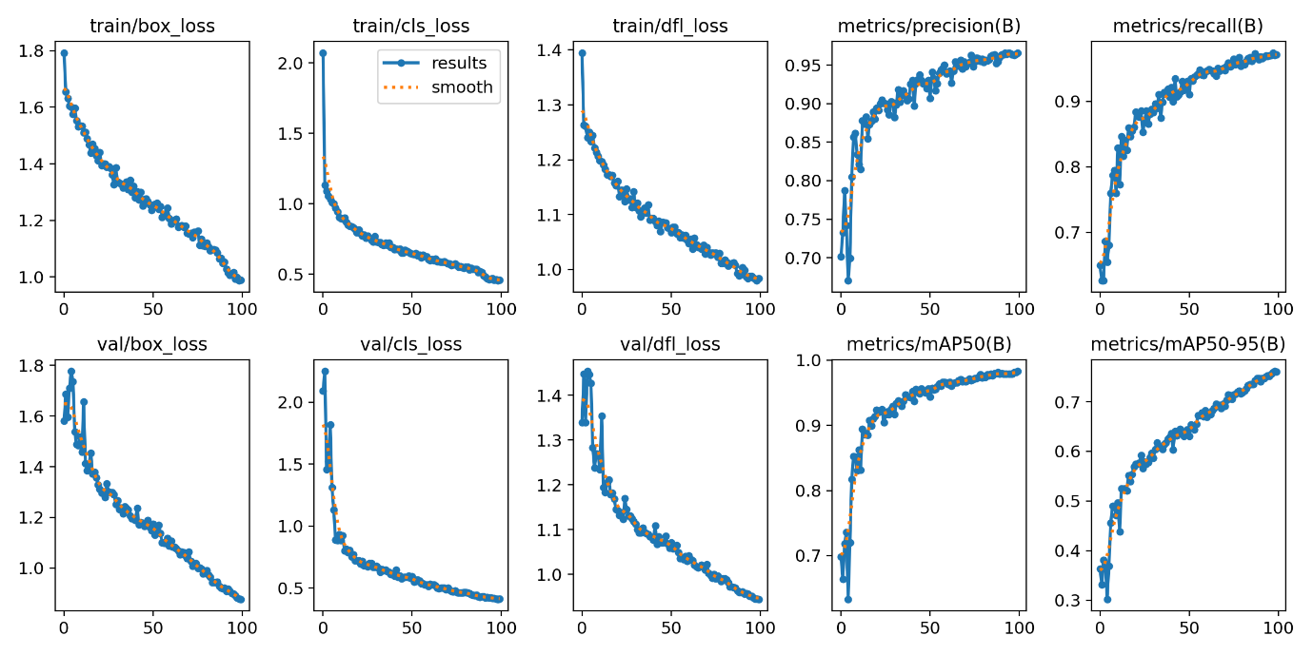

**Test Results**

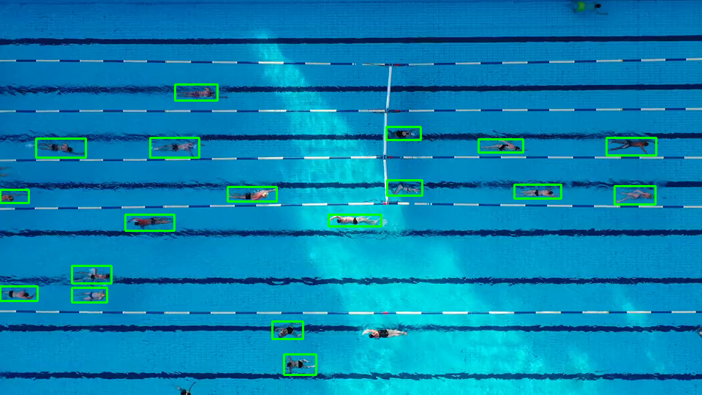

**Coco to YOLO Code**